Comments from the customer 22/05/2017

1.- Little points: It's not posible to see properly the Schedule/calendar selectiong the leave days.

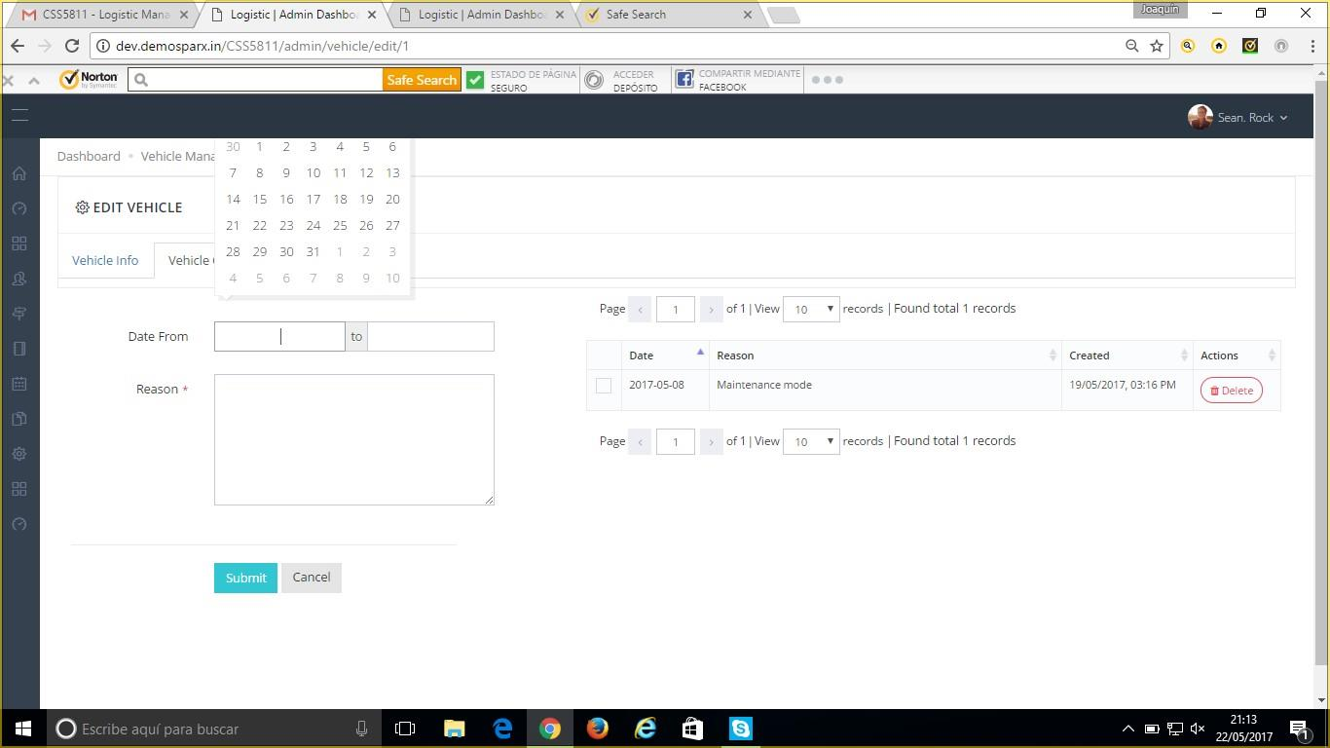

2.- As well in the description it's asking minimum of 10 characters.

3.- We want to change the emplyees in the column horizontal and the days in to the vertical line.

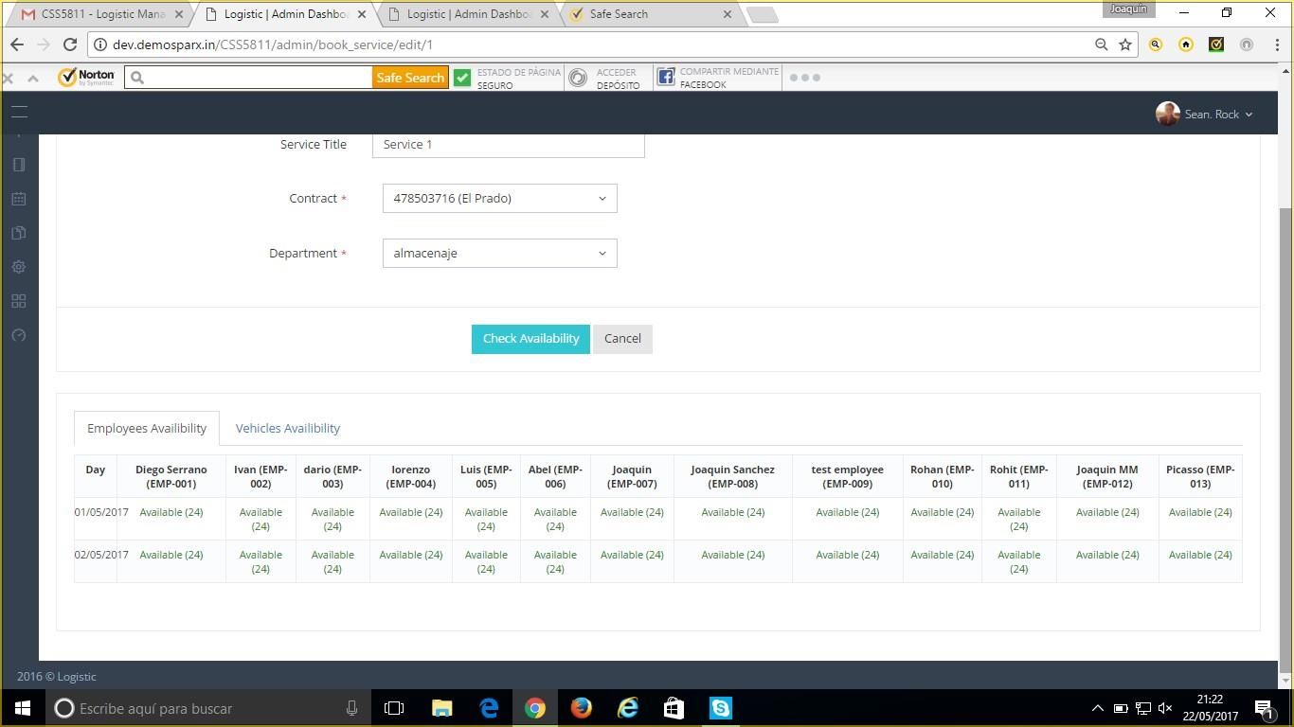

The reason is because there are more tan 100 emplyees and in vehicles the same.

4.- Full day box: We need a option click where the manager is selecting the full day and if the manager wants to add extra time he can do it manually.

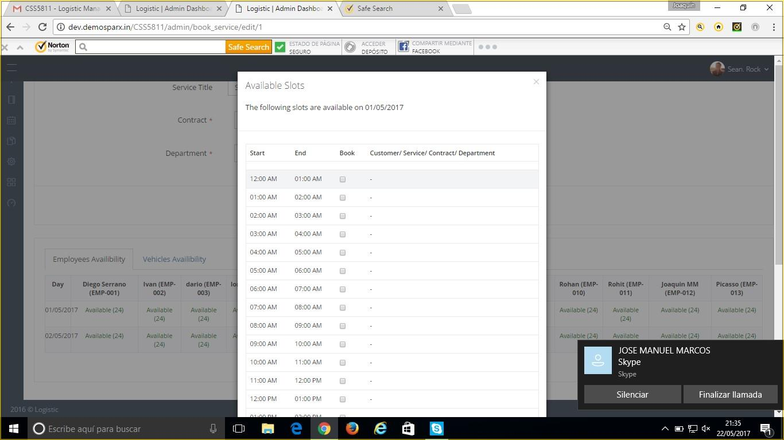

Because if not the manager is going to pass the whole day clicking.